National College of Computer Studies
Paknajol, Kathmandu

Project On
“Krishna Bakery”
as required for the partial fulfillment of the
B.Sc.CSIT 6th Semester affiliated to
Tribhuvan University

Submitted by: Submitted to:
Raj Babu Jirel Pratikshya Poudel
Sashant Dangol
Sec: B
National College of Computer Studies (NCCS)

Supervisor’s Recommendation

I hereby recommend that this project prepared under my supervision by Raj Babu Jirel and Sashant Dangol titled “KRISHNA BAKERY E-COMMERCE WEB APPLICATION” in partial fulfillment of the requirements for the degree of Bachelors in Computer Science and Information Technology be processed for the evaluation.

……………………………………
Pratikshya Poudel
National College of
Computer Studies
NCCS College

National College Of Computer Studies(NCCS)

Student’s Decleration

I hereby declare that we two are the sole author of this work and that no sources other than that listed here have been used in this work.

…………………………………………
Raj Babu Jirel
Sashant Dangol

NCCS College
National College of Computer Studies

Letter of Approval

This is to certify that this project prepared by Raj Babu Jirel and Sashant Dangol entitled “KRISHNA BAKERY E-COMMERCE WEB APPLICATION” in partial fulfillment of the requirements for the degree of B.Sc. in Computer Science and Information Technology has been well studied. In our opinion it is satisfactory in terms of scope and quality as a project for the required degree.

………………………………..
Pratikshya Poudel
Supervisor
National College of Computer Studies

Acknowledgement

We would like to express our deepest gratitude to NCCS College for providing the resources, platform, and unwavering support that made this project possible. The opportunities and guidance offered by the institution have been invaluable in shaping the direction and success of our work.
Our heartfelt thanks go to Ms. Pratikshya Poudel, our esteemed lecturer, whose invaluable guidance, expertise, and encouragement have been instrumental in overcoming challenges and maintaining the quality of this project. Your mentorship has inspired and motivated us throughout this journey.
We also extend our sincere appreciation to our families, friends, and all the participants for their steadfast encouragement and thoughtful contributions. Your unwavering support has been a constant source of strength, inspiring us to give our best at every stage.
In conclusion, we are profoundly thankful to NCCS College, Ms. Pratikshya Poudel, and everyone who contributed to bringing this project to fruition. Your collective efforts and support have been the foundation of its success.

Thanking You,

Raj Babu Jirel,
Sashant Dangol
BSc.CSIT 6th Semester

Abstract

Krishna Bakery is a web-based e-commerce application designed to provide an online platform for browsing and purchasing bakery products. The system allows users to explore various bakery items such as cakes, cookies, and bread through a visually appealing and easy-to-use interface. The application is developed using HTML, CSS, JavaScript, and PHP, with Khalti payment gateway integration for online transactions.
The system includes essential features such as a home page with product categories, product catalog, shopping cart functionality, user authentication, and secure checkout. Users can add products to the cart, increase or decrease item quantities, clear the cart, and proceed to checkout after logging in. Upon successful payment via Khalti, users are redirected to the home page.
The project aims to demonstrate the core concepts of an e-commerce system while focusing on usability, responsiveness, and secure payment integration. Krishna Bakery serves as an academic model for understanding online retail systems in the food and bakery domain.

Table of Contents
Contents
Supervisor’s Recommendation 2
Student’s Decleration 3
Letter of Approval 4
Acknowledgement 5
Abstract 6
Table of Figure: 9
LIST OF ABBREVIATIONS 10
CHAPTER 1: INTRODUCTION 11
1.1 INTRODUCTION 11
1.2 PROBLEM STATEMENT 12
1.3 OBJECTIVE 13
1.4 SCOPE 14
1.5 REPORT ORGANIZATION 15
CHAPTER 2: BACKGROUND STUDY 18
2.1 BACKGROUND STUDY 18
CHAPTER 3: SYSTEM ANALYSIS AND DESIGN 21
3.1 SYSTEM ANALYSIS 21
3.2 SYSTEM DESIGN 33
CHAPTER 4: IMPLEMENTATION AND TESTING 35
4.1 IMPLEMENTATION 35
4.2 TESTING 35
CHAPTER 5: CONCLUSION AND FUTHER RECOMMENDATION 37
5.1 LESSON LEARNT /OUTCOME 37
5.2 CONCLUSION 37
5.3 FUTURE RECOMMENDATION 37
References 38
Appendices 39

Table of Figure:

Figure 1: System Analysis and Design 22
Figure 2: DFD Level 0 25
Figure 3: ER Diagram 25
Figure 4: Flowchart 26
Figure 5: Use Case Diagram 28
Figure 6: Activity Diagram of Admin 29
Figure 7: Sequence Diagram 32
Figure 8: Three tire architecture 33
Figure 9: Database Scheme 34
Figure 10: Home Page of Krishna Bakery 39
Figure 11: Product page of Krishna Bakery 40
Figure 12: About Us page of Krishna bakery 40
Figure 13: Contact Page of Krishna Bakery 40
Figure 14: Shopping Cart for Krishna Bakery 41
Figure 15: Login Page for Krishna Bakery 41
Figure 16: Khalti Payment Integration 42

LIST OF ABBREVIATIONS

CSS: Cascading Style Sheets
DFD: Data Flow Diagram
ERD: Entity Relationship Diagram
HTML: Hypertext Markup Language
JS: JavaScript
MySQL: My Structured Query Language
PHP: Hypertext Preprocessor

CHAPTER 1: INTRODUCTION

1.1 INTRODUCTION
With The rapid growth of e-commerce has significantly transformed the way consumers purchase products, particularly in the technology sector where convenience, product comparison, and online payment systems play a crucial role. With the increasing demand for smartphones and related accessories, there is a strong need for reliable and user-friendly online platforms that simplify the buying process while ensuring security and efficiency.
Techie Roo is a modern e-commerce platform designed to facilitate the online sale of mobile phones and accessories. The system enables customers to browse products, search for specific items, manage shopping carts, and complete purchases through secure payment gateways. The platform also incorporates role-based access for administrators and customers, ensuring effective management of products, orders, and users.

1.2 PROBLEM STATEMENT
Before this system, customers had difficulty knowing what products were available and how to purchase them easily. Payments were handled manually, and communication between customers and the store was not well organized. These problems made the buying process slow and less user-friendly.

The main problems identified are:
• Limited Access to Products: Customers could only check products by visiting the store or calling the seller, which was not always convenient and could be time consuming.
• Manual Payment Process: Without an online payment option, customers faced delays and inconvenience while making payments. Withdrawing and delivering large amount of cash could be a hassle to the customers.
• Poor Communication System: Customers did not have a simple way to confirm orders or ask questions directly through an online platform. It could cause customers to have confusions and question about the product, its availability along with its feature.
To overcome these problems, TECHIE ROO provides an online platform where customers can view mobile phones and accessories, place orders, and make payments using the Khalti payment gateway. The website also includes WhatsApp integration, allowing customers to communicate easily with the store for order confirmation and support. This system makes the buying process faster, easier, and more reliable while improving the overall shopping experience

1.3 OBJECTIVE

The main objective of the TECHIE ROO: E-COMMERCE MOBILE PHONE STORE project is to create an easy-to-use online platform for selling mobile phones and accessories. The system aims to reduce the need for physical store visits by providing customers with a convenient way to browse products and place orders online.

The specific objectives of the project are:

- To develop a user-friendly website for displaying mobile phones and accessories.

- To allow customers to place orders and make secure online payments using the Khalti payment gateway.

- To provide direct communication between customers and the store through WhatsApp integration.

- To manage user accounts with secure login and registration features.

- To support different user roles such as admin, salesperson, and customer.

- To improve efficiency in order handling and customer service through digital processes.

1.4 SCOPE
The TECHIE ROO is developed to provide an easy and efficient online platform for selling mobile phones and accessories. The system focuses on improving customer convenience through digital product browsing, ordering, payment, and support services.

The scope of the system includes:
• Product Catalogue with Discount Offers:
The website displays a catalogue of mobile phones and accessories with product details such as price, images, and descriptions. The catalogue also includes discounts and special offers, allowing customers to view reduced prices while browsing products.
• Online Shopping and Order Placement:
Customers can select products, add them to a shopping cart, and place orders using a simple and user-friendly interface.
• Secure Payment through Khalti:
The system supports secure online transactions by integrating the Khalti payment gateway, ensuring safe and reliable payments.
• Order Management:
Customers can view order details after purchase, while admins and salespersons can manage and update order status.
• Customer Registration and Account Handling:
Users can create accounts, log in securely, update personal information, and view order history.
• Customer Support via WhatsApp:
The system provides WhatsApp integration as a customer support feature, enabling customers to communicate easily with the store for inquiries, order confirmation, and delivery support.
• Role-Based Access Control:
Different user roles such as admin, salesperson, and customer are supported, each with specific permissions.About Us and Contact Us sections integrated into a single page

1.5 REPORT ORGANIZATION

1.5.1 Introduction
This report depicts the development of TECHIE ROO an online platform designed for selling mobile phones and related accessories. The website provides a convenient digital environment where customers can easily browse products, view details, place orders, and make secure payments. The main goal of this project is to enhance customer accessibility, simplify the purchasing process, and improve overall shopping experience by providing a smooth, efficient, and user-friendly online platform.

1.5.2 Background Study
TECHIE ROO was conceptualized to meet the growing demand for online mobile phone shopping. Traditional mobile phone retail often requires customers to visit stores physically, which can be time-consuming and limits accessibility. With the rise of digital technology, customers now prefer to shop online for convenience, quick access to product information, and secure payment options.

The mobile phone market has been shifting toward e-commerce, as consumers increasingly value ease of access, variety of products, and transparent pricing. Additionally, direct communication with the store for order confirmation and support has become an important factor in customer satisfaction.
1.5.3 System Analysis and Design
The development of TECHIE ROO: E-COMMERCE MOBILE PHONE STORE requires a thorough system analysis to ensure that the platform meets the requirements of both the business and its customers. This phase involves understanding user needs, defining system functionalities, designing the architecture, and selecting appropriate technologies to build a reliable and scalable online store..

System Requirements:
Functional Requirements:
- The system should allow customers to browse products, view product details, and see available discounts and offers.
- Users should be able to add products to the shopping cart, place orders, and complete secure online payments through the Khalti payment gateway.
- Customers can register, log in, and manage their accounts, including viewing order history.
- Admins should be able to manage products, orders, and user information through a dedicated admin panel.
- The system should support multiple user roles such as admin, salesperson, and customer, each with specific access permissions.

Non-Functional Requirements:
- The Navigation should be simple and intuitive for all users.
- Security measures, such as secure login and safe payment processing, should be in place.
- The system should maintain data integrity, handle multiple users and orders efficiently, and provide reliable performance without downtime.
- WhatsApp integration must be included to allow customers to communicate directly with the store for order confirmation, support, and delivery updates

- System Design:
Frontend Design: The user interface (UI) is designed to be simple, clear, and easy to navigate.
- The homepage highlights featured products, ongoing offers, and product categories.
- Product pages display images, descriptions, specifications, pricing, and available discounts.
- The design is fully responsive, ensuring smooth usage across desktops, tablets, and mobile devices.

Backend Design:
• The backend is built using Node.js with Express.js, providing a reliable and scalable server environment.
• SQLite3 is used as the database to store product information, user accounts, and order history.
• The admin panel allows management of products, orders, and customer data.
• Salespersons have access to assigned orders to update status and communicate with customers.

Technology Stack:
- HTML, Frontend: HTML5, CSS3, and JavaScript for interactive and responsive design.
- Backend: Node.js and Express.js for server-side operations.
- Database: SQLite3 for efficient storage and retrieval of data.
- Payment Integration: Khalti for secure online transactions.
- Customer Support: WhatsApp integration to allow direct communication with customers.

This design ensures that the website is secure, reliable, and easy to use, while providing all essential e-commerce features such as product browsing, ordering, payment, and customer support

1.5.4 Implementation and Testing
The development process consists of implementation and testing phases to ensure proper system functionality.

Implementation:
- Frontend design: It based on wireframes and mockups, focusing on simplicity and ease of use. The website is built using HTML, CSS, and JavaScript, making it responsive and accessible on desktops, tablets, and mobile devices. Product pages display high-quality images, descriptions, pricing, and any available discounts or offers. The homepage highlights featured products and categories to guide customers through the shopping process effectively.
- Backend: The system uses Node.js and Express.js to manage server-side operations. User authentication, account management, product management, shopping cart functionality, and order processing are implemented to provide a seamless experience. The platform supports multiple roles, including admins, salespersons, and customers, each with specific permissions.
- Payment Integration: It is integrated securely using the Khalti payment gateway, ensuring safe online transactions.
In addition, WhatsApp integration allows customers to communicate directly with the store for order confirmations, delivery updates, and general support, enhancing the overall shopping experience.

Testing:
Unit Testing:
- Testing individual components like the shopping cart, order system, and payment integration to ensure they work correctly.
Integration Testing:
- Testing how different parts of the system (frontend and backend) work together to prevent errors and ensure smooth operation.
User Acceptance Testing (UAT):
- Having a group of users try the website to check usability, functionality, and performance.
Load Testing:
- Testing the website’s ability to handle multiple users and high traffic without slowing down or crashing.

1.5.5 Conclusion and Further Recommendations
TECHIE ROO: E-COMMERCE MOBILE PHONE STORE is a major step forward for mobile phone retail. It allows the business to reach more customers and provides a convenient, secure, and user-friendly shopping experience. With features such as Khalti payment integration, WhatsApp-based customer support, and a catalogue that shows discounts and special offers, the platform improves customer satisfaction and streamlines business operations. Robust development and testing ensure the website is reliable, scalable, and secure for future growth.

Further Recommendations:

- Mobile App Development: Developing a mobile app would allow customers to shop on their smartphones, increasing convenience and engagement.

- Search Engine Optimization (SEO): Optimizing the website for search engines can attract more visitors and potential customers.

- Enhanced Customer Support: Adding features like live chat or a chatbot could provide real-time assistance and improve customer satisfaction.

- Marketing and Promotions: Using email campaigns, seasonal offers, and discount codes can increase sales and encourage repeat purchases.

- Regular Updates: Continuously updating the website with new products, features, and offers keeps the platform engaging and relevant.

By following these strategies, TECHIE ROO can strengthen its presence in the competitive e-commerce

CHAPTER 2: BACKGROUND STUDY

2.1 BACKGROUND STUDY
This study focuses on the development of TECHIE ROO, an online platform for selling mobile phones and accessories. The main goal is to provide customers with an easy and efficient way to browse and purchase products from anywhere, without visiting a physical store. We analyzed existing e-commerce websites in the mobile phone and electronics retail industry to identify key features such as a clear product catalogue, user-friendly navigation, secure payment integration, and effective communication channels like WhatsApp for customer support.
Additionally, we explored secure and popular payment gateways, such as Khalti, to ensure smooth and safe transactions. Literature and case studies on similar online retail platforms were also reviewed to understand how digital solutions can help small-to-medium businesses grow online and improve the customer shopping experience. This research provides the foundation for building a reliable, user-focused e-commerce platform tailored for both casual buyers and tech enthusiasts.
2.1.1 STUDY OF EXISTING SYSTEM

Online Online Shop

• Product Range: Offers a wide variety of Apple products, including iPhones, iPads, MacBooks, AirPods, Apple Watches, and accessories.
• User Tools: Provides product comparison tools, specifications, and warranty information.
• Shopping Experience: Features an intuitive interface with a secure shopping cart system.
• Mobile Responsiveness: Fully optimized for mobile devices, providing smooth browsing and checkout. (Apple Team, 2024)

Samsung Online Store
Features:
- Product Range: Offers smartphones, tablets, smartwatches, and accessories.
- User Tools: Includes product comparison, detailed specifications, and warranty info.
- Shopping Experience: Easy-to-use interface with secure payment and smooth navigation.
- Mobile Responsiveness: Optimized for smartphones and tablets. (Samsung Team, 2025)

Daraz Mobile & Electronics Section
Features:
- Product Categories: Includes Apple products along with other smartphones, accessories, and gadgets.
- Exclusive Deals: Offers flash sales, discounts, and limited-time promotions.
- User Engagement: Encourages registration for personalized offers and updates.
- Mobile Compatibility: Fully mobile-friendly for convenient shopping. (Daraz Team, 2025)

Pick n Buy Electronics
Features:
- Product Offerings: Stocks Apple and other top-brand smartphones, tablets, chargers, headphones, and cases.
- User Experience: Provides detailed product descriptions, images, ratings, and reviews for informed purchasing.
- Mobile Compatibility: Optimized for mobile devices for on-the-go browsing and purchasing. (Pick n Buy Team, 2024)
.

Designing a Mobile Electronics E commerce: A UX Case Study
- Insights:
- User- Centric Design: Highlights the need for clear categories, visible cart icons, and smooth navigation.
- Prototyping and Testing: Emphasizes detailed wireframes to match user expectations for fast and easy browsing.
- Checkout Process: Focuses on creating secure, quick, and simple checkout flows. (UX Team, 2024)
- The Best Examples of Successful Shopify Hardware Stores 2023
- Insights:
- Platform Platform Utilization: Examines how businesses use custom websites or Shopify to sell branded devices, including Apple products.
  - Feature Implementation: Discusses integrating secure payments, WhatsApp support, and promotional offers to enhance customer experience. (Market Research Team, 2025

2.1.2 LITERATURE REVIEW

The Integration of Branded Products
Selling branded products like Apple devices requires features that enhance the shopping experience, such as detailed specifications, images, pricing, and warranty information. E-commerce platforms can also offer promotional discounts and special offers to attract and retain customers. TECHIE ROO integrates these features along with WhatsApp-based customer support to improve communication and service quality.

Web Technologies for E-Commerce
Developing an online store like TECHIE ROO requires modern web technologies. HTML, CSS, and JavaScript are used to create a responsive, interactive, and user-friendly interface. The backend, built with Node.js and Express.js, manages secure user authentication, product listings, order processing, and inventory management. Integration with the Khalti payment gateway ensures safe and smooth online transactions.

User Experience and Functionality
User experience is a critical aspect of e-commerce platforms. TECHIE ROO focuses on providing an easy-to-use interface, displaying featured products, discounts, and offers, and allowing customers to track their orders. WhatsApp integration enhances customer support, enabling real-time communication for queries, order confirmation, and delivery updates. These features create a secure, efficient, and enjoyable shopping experience.

Conclusion
TECHIE ROO demonstrates how mobile phone retailers can succeed online by combining modern web technologies, secure payment systems, branded products like Apple devices, and customer support integration. The platform provides a user-friendly, feature-rich environment that improves accessibility, convenience, and overall satisfaction for customers

CHAPTER 3: SYSTEM ANALYSIS AND DESIGN

3.1 SYSTEM ANALYSIS
The system analysis phase for TECHIE ROO is critical for identifying the website’s requirements and ensuring that it meets both business goals and customer expectations. This phase guides the design and development of an effective e-commerce platform for selling mobile phones, accessories, and branded products such as Apple devices. An incremental delivery approach is used to develop the system in manageable stages, allowing continuous improvement and feedback.
The process includes:
• Requirement Analysis: Identifying both functional and non-functional requirements in increments. Functional requirements include product catalog display, shopping cart functionality, Khalti payment integration, discount and offer display, order tracking, and WhatsApp-based customer support. Non-functional requirements focus on performance, security, responsiveness, and scalability to support future growth.
• System Design: Designing the system architecture in a modular manner, including the frontend (user interface) and backend (server-side logic and database). The design allows features to be added gradually, ensuring smooth integration of product listings, payment processing, and order management.
• Implementation and Development: Developing the system in multiple increments. Initial development includes basic website layout and product display. Later increments add user registration and login, cart management, payment integration through Khalti, and WhatsApp customer support, ensuring the system remains user-friendly and functional at each stage.
• Testing: Conducting testing after each increment. Functional testing ensures features work correctly, performance testing checks system responsiveness, and security testing ensures safe transactions and data protection.
• Deployment: Deploying each completed increment and monitoring system performance. Issues are identified early, and improvements are made based on user feedback before moving to the next increment.
This structured incremental approach ensures that TECHIE ROO’s e-commerce website is designed, developed, and deployed as a secure, reliable, and user-friendly online shopping. 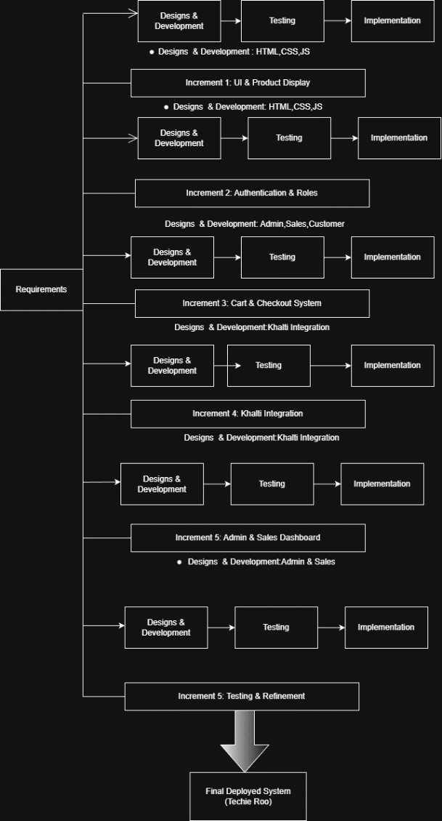
Figure 1: System Analysis and Design

3.1.1 REQUIREMENT IDENTIFICATION
Requirement Identification is a vital step in the system analysis phase of software development. It involves identifying and defining the essential needs and expectations that the system must fulfill to operate effectively. This process ensures that the website aligns with business objectives and provides a satisfactory experience for users. For TECHIE ROO – E-COMMERCE MOBILE PHONE STORE, requirements are categorized into functional and non-functional requirements
3.1.1.1 Functional Analysis
The functional requirements are:
- Product Catalog: The The website must display a variety of mobile phones, accessories, and branded products such as Apple devices. Each product should include detailed information such as name, specifications, price, images, discount offers (if available), and stock availability.

- User Account Management: Customers should be able to register, log in securely, and manage their personal information and order history through their accounts.
- Shopping Cart: The system should allow customers to add products to the cart, modify quantities, remove items, and proceed to checkout smoothly.
- Order Management: Users should be able to place orders, view order details, and track the status of their orders after purchase.
- Payment Integration: A secure payment system should be integrated using the Khalti payment gateway to process online transactions safely and reliably.
- Admin Panel: The administrator should be able to manage product listings, update prices and discounts, control inventory, and view customer orders through an admin dashboard.
- Customer Support: The website should provide WhatsApp integration to allow customers to directly contact the store for inquiries, order confirmation, and delivery-related support.

Non-Functional Analysis

- Non-functional requirements describe how the system performs rather than the functions it provides. In the context of our website the non-functional requirements are as follows:
- Security: User information and payment data must be protected using secure authentication methods, encrypted communication, and safe transaction handling, especially during Khalti payment processing.
- Usability: The website should be easy to use, with a simple and intuitive interface that is accessible to both experienced and first-time users.
- Performance: The website should load quickly and respond efficiently, even during periods of high traffic, to ensure a smooth and reliable shopping experience.
- Reliability:
The system should operate consistently without frequent failures. Orders, payments, and user data should be processed accurately every time

3.1.2 FEASIBILITY STUDY
A feasibility study for "Techie Roo : Mobile Ecommerce websit", is essential to determine the project's viability, potential for success, and any challenges that may arise. The feasibility study typically includes several key components:
3.1.2.1 Technical Feasibility
- Platform & Technology: The website will be developed using HTML5, CSS3, and JavaScript for front-end interface, Node.js and Express.js for back-end, and SQLite3 for database management. This tech stack is lightweight, scalable, and suitable for e-commerce applications.
- Payment Gateway Integration: Integrating Khalti payment gateway for secure and convenient online transactions for Nepali customers, along with WhatsApp integration for direct customer communication and order confirmation.
- Mobile Responsiveness & Security: Ensuring mobile compatibility for diverse user devices and implementing JWT (JSON Web Tokens) for authentication and bcryptjs for password encryption to ensure data protection.

      - Operational Feasibility
- Inventory Management: Implementing an automated inventory system that updates stock levels in real-time for mobile phones and accessories, with easy categorization by brand, model, and specifications.
- Order Fulfillment: Establishing relationships with local logistics companies to ensure timely product delivery, along with WhatsApp integration for real-time order tracking and customer communication.
- Customer Support: Setting up WhatsApp integration and role-based dashboards to handle customer inquiries, returns, and service issues efficiently through admin and salesperson portal.

3.1.2.3 Schedule Feasibility
- Development Development Timeline: The development of the e-commerce site is estimated to take 3–4 months depending on complexity. This includes design, Node.js/Express.js back-end setup, SQLite database configuration, Khalti payment integration, WhatsApp API integration, and testing.
- Launch Plan: A phased launch with initial promotions, discounts for early adopters, and a digital marketing campaign (e.g., SEO, social media, email newsletters) to generate traffic and initial sales.

3.1.3 DATA MODELING
Data modeling is essential to organize and structure the data required for an e-commerce website. It ensures that information can be stored efficiently, retrieved quickly, and managed effectively. For TECHIE ROO, data modeling involves identifying key entities, their attributes, and relationships between them.

3.1.3.1 Data Flow Diagram
A Data Flow Diagram (DFD) is a visual representation of the flow of data within a system, focusing on how data enters, is processed, and exits the system. It helps understand the logical structure of the system, including key processes, data stores, and data sources/destinations.
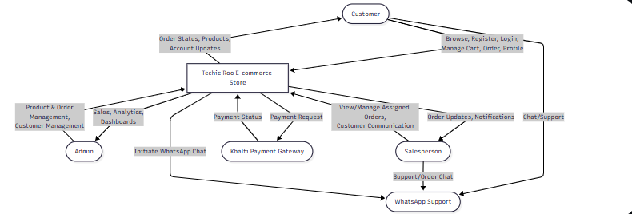
Figure 2: DFD 0 level diagram

3.1.3.2 ER Diagram
An Entity-Relationship (ER) diagram is a visual representation of the entities within a system and the relationships between them. In the context of the Techie Roo mobile phone e-commerce website an ER diagram helps to organize and structure data to facilitate efficient database design
TECHIE ROO E COMMERCE WEBSITE ER

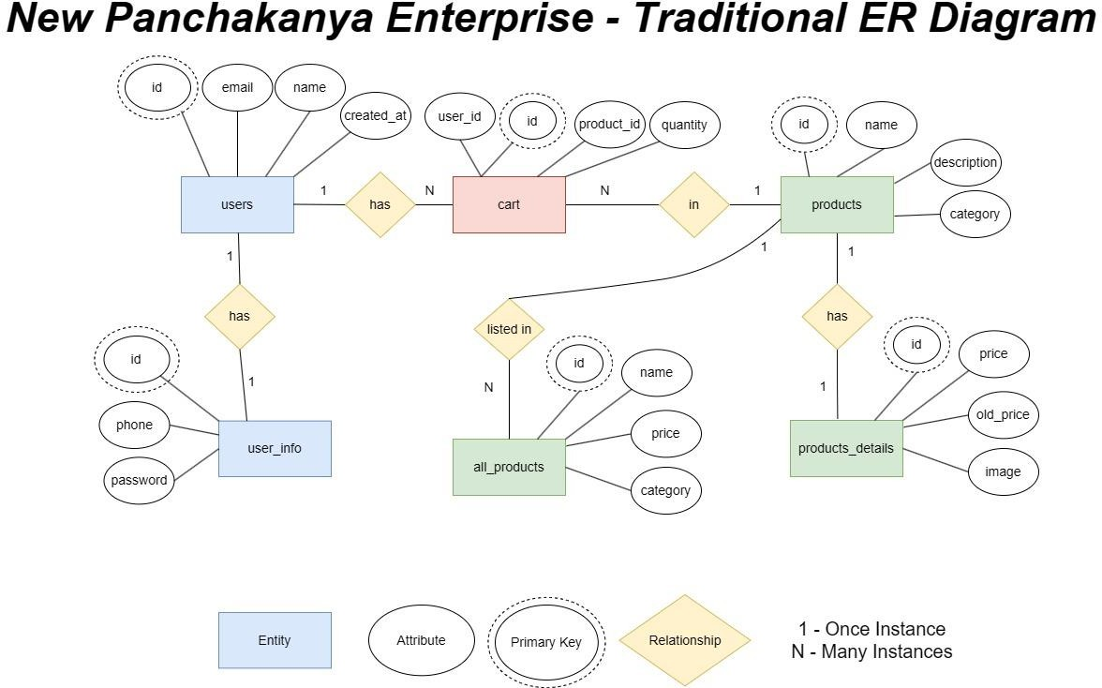
Figure 3: ER Diagram

3.1.4 PROCESS MODELING
For Techie Roo mobile phone e-commerce website, the process modeling would describe the flow of operations, from the customer’s browsing experience to the final order placement and delivery. Below is a structured breakdown of the process model using relevant diagrams.
3.1.4.1 Flow Chart:
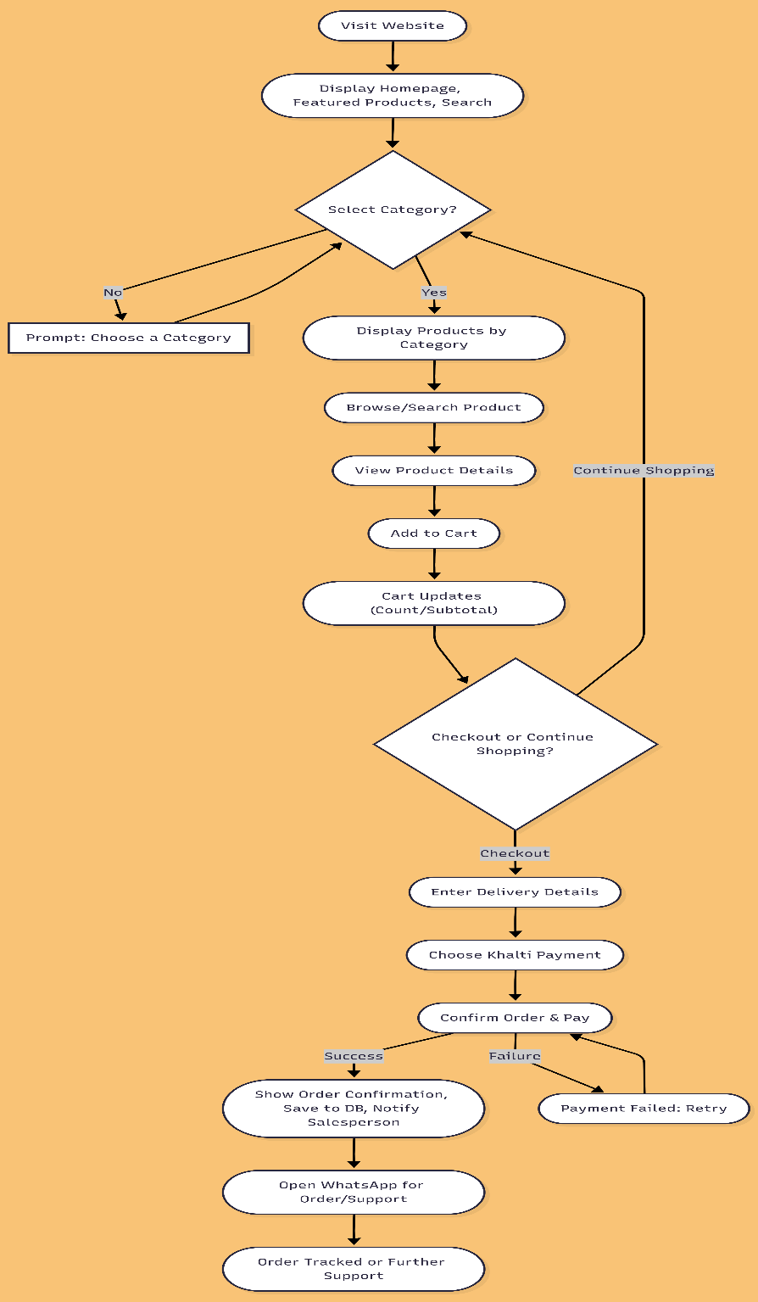

Figure 4: Flowchart

This Steps in the flowchart are as follows:
Step 1: Visit Website
- The user accesses the Techie Roo homepage: http://localhost:3000 (or live domain).
- Featured products, categories (e.g., Smartphones, Accessories), and a search bar are displayed.
Step 2: Category Selection
- Users can select a category to browse products: Smartphones, Chargers, Headphones, Cases, etc.
- Validation:
  - If no category is selected, a prompt guides the user to choose one.
  - Once selected, all products in that category are displayed.
Step 3: Browse and Search Items
- Users can browse products within the chosen category.
- Use the search bar to quickly find a specific product by name, brand, or model.

Step 4: Select Product and Add to Cart
- The user selects a product to view details (images, specifications, price, stock).
- Clicks “Add to Cart” to include it in the shopping cart.
- The shopping cart updates dynamically, showing item count and subtotal.
Step 5: Proceed to Checkout
    - Enter delivery details (address, phone number).
    - Choose Khalti as the payment method.
    - Confirm the order and complete the payment.

Step 6: Continue Shopping
    - Return to browsing products without checking out.
Step 7: Order Confirmation
- Upon successful payment:
  - An order confirmation is displayed on the website.
  - Order details are stored in the database.
  - Assigned salesperson receives a notification if applicable.
Step 8: Customer Support
- The website includes a WhatsApp icon for customer support.
- Users can click the icon to send messages or inquiries to the store directly.
- This allows seamless communication for questions, complaints, or assistance.
Outcome:
This workflow ensures a smooth shopping experience for Techie Roo customers, integrating search-based product discovery, Khalti payment, and WhatsApp support for customer communication.

3.1.4.2 Use Case Diagram
The Use Case Diagram illustrates the interaction between Customers and Techie Roo system.
Key functionalities for Customers include:

        - Browsing Phone, charger etc:-
- Searching for products by category, brand (e.g., Samsung phone), or keywords
        - Viewing product details, including images, descriptions, and specifications.
        - Adding products to the cart.
        - Check out options for delivery or pickup.
        - Entering billing and shipping information.
        - Selecting payment methods.
        - Tracking order status.
        - Viewing order history.

Admin functionalities include:

        - Managing product catalog (adding, editing, deleting products).
        - Managing inventory levels.
        - Processing orders.
        - Managing customer accounts.
        - Generating sales reports.
- Handling customer inquiries
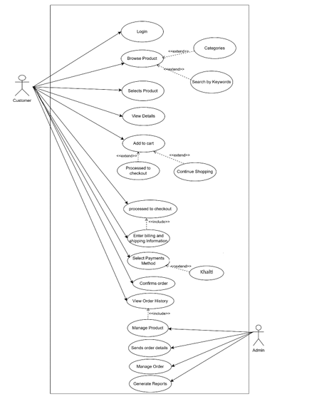
Figure 5: Use Case Diagram

3.1.4.3 Activity Diagram
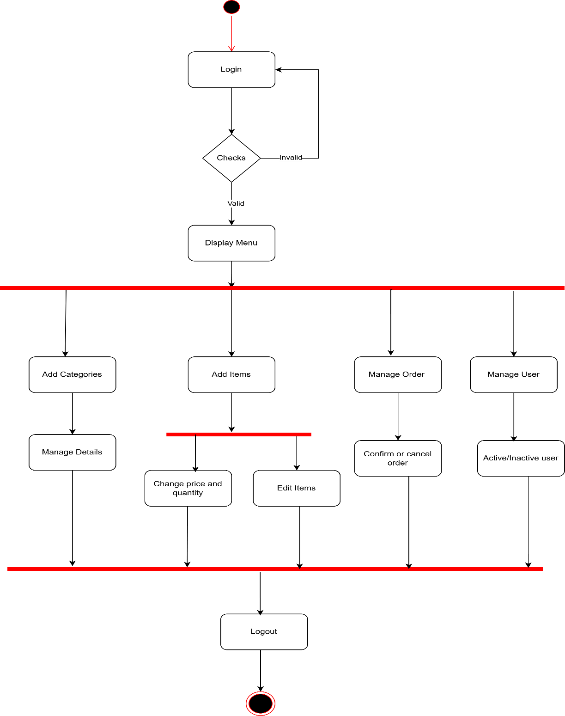
Figure 6: Activity Diagram of Admin

Key activities for admin include:

        - Login and authentication: The process begins with the admin logging into the system, followed by authentication to verify their credentials.
        - Category Management: The admin can add new categories, modify existing ones, and manage their details.
        - Item Management: The admin can add new items, edit existing items, and adjust their price and quantity.
        - Order Management: The admin has the authority to manage orders, including confirming orders and canceling orders as needed.
        - User Management: The admin can manage user accounts within the system, enabling or disabling user accounts based on requirements.

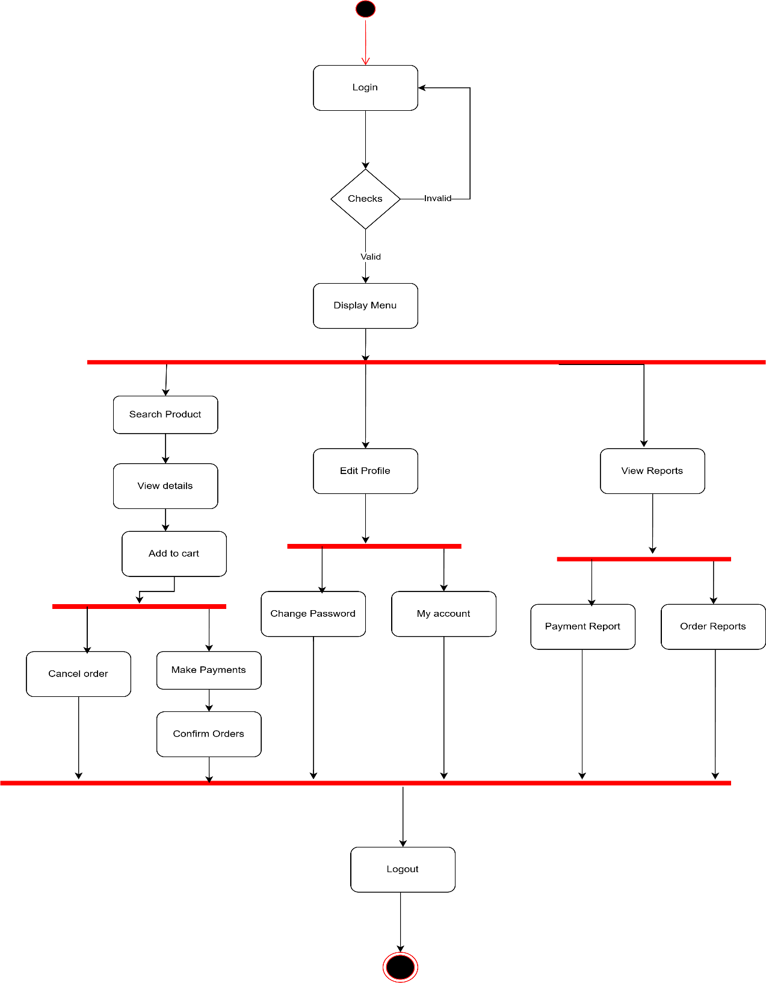Figure 7: Activity Diagram of Customer

Key activities for customers include:

        - Login and Authentication: The user starts by logging into the system, followed by authentication to verify their credentials.
        - Product Exploration: Users can search for products, view product details, and add items to their cart.
        - Account Management: Users can edit their profile, change their password, and view their account information.
        - Order Management: Users can make payments, confirm orders, and cancel orders if needed.
        - Reporting: The system provides access to view reports, including payment reports and order reports.

3.1.4.4 Sequence Diagram
The sequence diagram represents the interaction between a User, the Web Browser, Techno Ree Server, the Database, and the Payment Gateway during various activities on an e-commerce website:
- Homepage Access:
- The user opens the website, and the browser requests the homepage from the server, which fetches data from the database and displays it to the user.
- Product Search:
- The user searches for products. The browser sends the query to the server, which retrieves matching products from the database and returns the results.
- Viewing Product Details:
- The user selects a product to view its details. The browser requests product information from the server, which fetches it from the database and displays it.

- Adding Products to Cart:
- The user adds a product to their cart. The browser sends this request to the server, which updates the cart information in the database and confirms the actions
- WhatsApp Support: Users can click the WhatsApp icon if they face issues or need assistance with using the website.
- Checkout:
- The user proceeds to checkout. The server retrieves carts and user details from the database and displays the checkout page.
- Payment:
- The user initiates payment. The browser communicates with the payment gateway, which notifies the server of payment success. The server updates the order status in the database and confirms the order to the user.
- Logout: The user logs out, and the server processes the logout request, confirming the action.
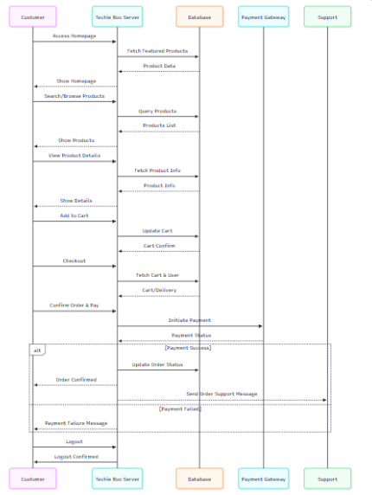

Figure 7:Sequence Diagram

3.2 SYSTEM DESIGN

3.2.1 Architectural Design
The three-tier architecture has been adopted for the Krishna Bakery e-commerce system. This architecture follows a client–server model where the user interface, application logic, and data storage are developed and maintained as independent layers. This separation improves scalability, security, and maintainability of the system.
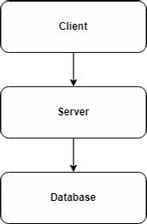
Figure 8 : Three tire architecture
Three-Tier Architecture has the following layers.
- Presentation Layer:
This layer represents the user interface of the Krishna Bakery website. It displays bakery products, categories, shopping cart, login pages, and checkout interfaces. Technologies such as HTML, CSS, and JavaScript are used to ensure responsive and interactive user experience
- Application Layer:
Also known as the business logic layer, this tier handles core functionalities such as user authentication, cart management, order processing, and Khalti payment integration. PHP is used to process requests received from the presentation layer and communicate with the database.
- Data Layer:
This layer stores and manages all system data, including user information, product details, cart data, and order records. The database is managed using MySQL through the XAMPP server environment.
The following are the reasons behind choosing three tier-architecture:
- Logical separation of user interface, application logic, and data storage.
- Easier maintenance and future upgrades.
- Improved system scalability and security.

3.2.2Database Schema Design
Database Database schema design is a strategy for constructing a framework for data management. Just like in architecture, a solid database needs to have a blueprint to keep the project on track.
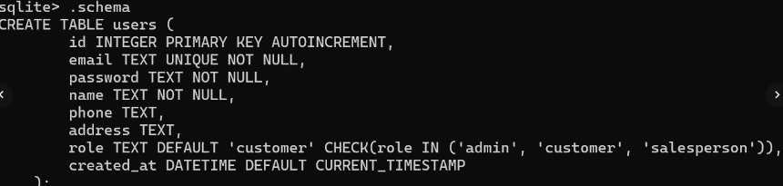

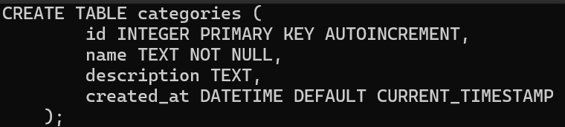

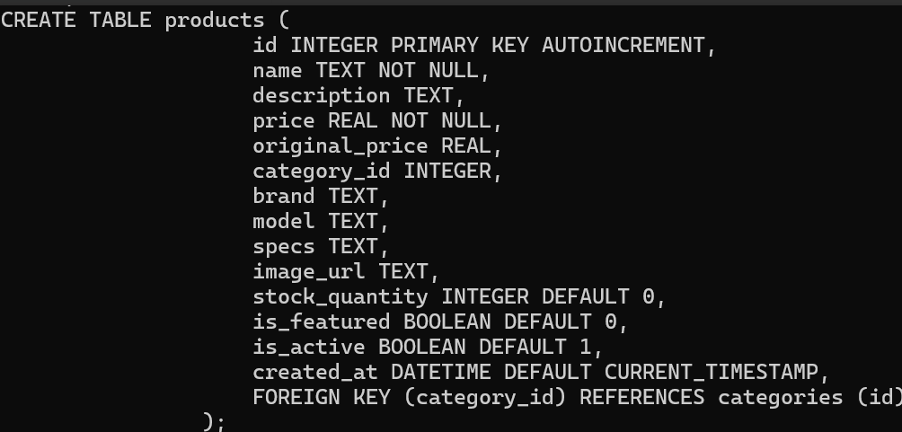

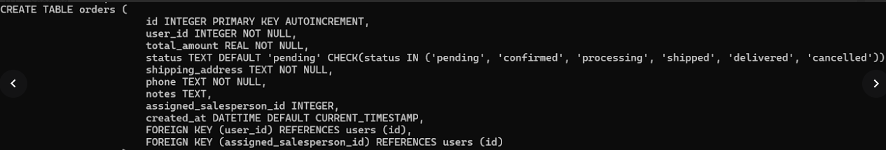
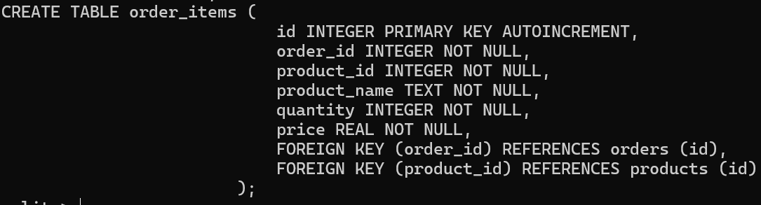 Figure 9: Database Scheme

CHAPTER 4: IMPLEMENTATION AND TESTING

4.1 IMPLEMENTATION

4.1.1 Tools used.
- Platform: Windows
- Content Management System: HTML, CSS
- Design and prototyping Tool: Mermaid
- Implementation Detail of Module
The implementation of Techie Roo, an e-commerce platform for mobile phones and accessories, was carried out using a combination of modern front-end and back-end technologies to provide a responsive, secure, and user-friendly shopping experience. The front-end was developed using HTML5, CSS3, and Vanilla JavaScript, ensuring compatibility across desktops, tablets, and mobile devices. Key features include product browsing by category, search functionality for quick product discovery, a dynamic shopping cart, secure user authentication, profile management, and a WhatsApp support icon for customer inquiries. The back-end was implemented using Node.js and Express.js, handling routing, API endpoints, and server-side logic. SQLite3 serves as the database for storing user information, products, orders, and categories, with automatic creation and sample data setup on the first run. Authentication is secured with JWT (JSON Web Tokens), and passwords are hashed using bcryptjs, while Multer handles file uploads and express-validator ensures input validation. The development environment included Visual Studio Code as the code editor and a Node.js local server for testing, with SQLite3 for database management. For payment processing, the Khalti payment gateway was integrated to provide secure online transactions, while a WhatsApp icon on all pages enables real-time customer support. The system implements role-based access control, differentiating features for Customers, Admins, and Salespersons, and supports all core e-commerce functionalities, including product listings, cart management, checkout, payment processing, order tracking, and management. Overall, the implementation focuses on delivering a smooth, efficient, and secure online shopping experience tailored for mobile phone customers

4.2 TESTING
System testing validates the complete and integrated Krishna Bakery system to ensure it meets functional and performance requirements. Testing focused on verifying cart operations, user authentication, and Khalti payment processing.
Test Case ID: 1
Test Title: Verify shopping cart and Khalti payment functionality.
Test Designed Date: April 2025
Pre-conditions: User has accessed the website and logged in.
Dependencies: Product database contains bakery products.

Table 1: Test Case 1
Test Case ID | Test Description | Test Data | Expected Result | Actual Result | Status
TC-01 | Add product to cart | Cake item | Product added to cart | Product added | Pass
TC-02 | Increase product quantity | + button | Quantity increases | Quantity increased | Pass
TC-03 | Decrease product quantity | – button | Quantity decreases | Quantity decreased | Pass
TC-04 | Clear cart | Clear cart | Cart emptied | Cart emptied | Pass
TC-05 | Checkout without login | No login | Redirect to login | Redirected | Pass
TC-06 | Khalti payment success | Valid payment | Redirect to home | Redirected | Pass

Post-condition: Cart and payment operations function correctly and system behaves as expected.

CHAPTER 5: CONCLUSION AND FUTHER RECOMMENDATION

5.1 LESSON LEARNT /OUTCOME
This project enhanced understanding of e-commerce system development, system analysis, database design, and web technologies. It provided practical experience in implementing shopping cart logic, payment gateway integration, and system modeling using diagrams.

5.2 CONCLUSION
Krishna Bakery is a web-based e-commerce platform that enables customers to browse and purchase bakery products online. Developed using HTML, CSS, JavaScript, and PHP with MySQL database support, the system offers essential features such as product categorization, shopping cart management, user authentication, and secure Khalti payment integration. The project demonstrates how a custom-built e-commerce solution can effectively support small local businesses through digital transformation.

5.3 FUTURE RECOMMENDATION
The project will be upgraded and extended with the following features:
- Improving UI/UX design and performance optimization.
- Developing a mobile application version
- Adding admin panel for product and order management.
- Enhancing security and scalability features.
- Integrating AI-based chatbot for customer support.

References
- https://www.youtube.com/watch?v=XAAoO-chVTc
- https://www.codexworld.com/shopping-cart-with-paypal-payment-gateway-in-php/
- https://docs.khalti.com/khalti-epayment/
- https://github.com/Deejs2/khalti-ePayment-gateway
- https://www.webassist.com/tutorials/eCommerce-Overview---eCommerce-Series- webassist.com
- https://www.webassist.com/tutorials/Add-a-shopping-cart-II--eCommerce-Series- webassist.com
- https://www.webassist.com/tutorials/eCart-checkout-payments--eCommerce-Series-
- https://www.geeksforgeeks.org/mern/e-commerce-websites-shopping-cart/

Appendices
Screenshots of output:

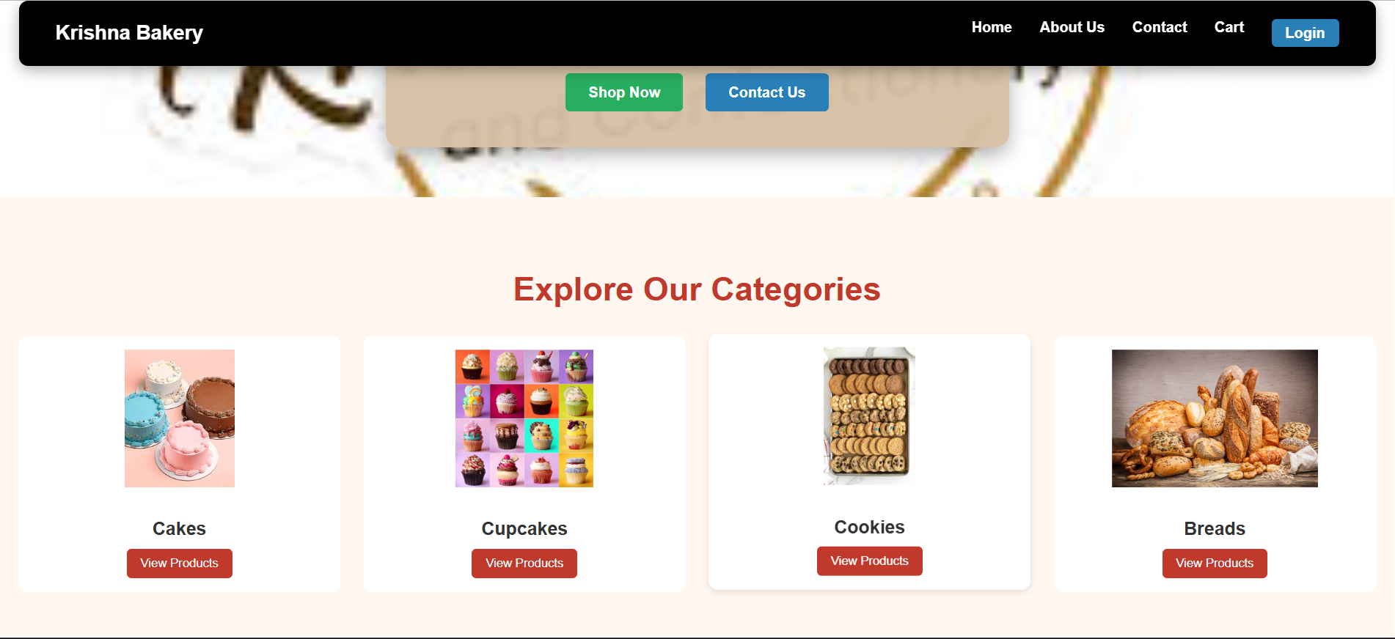
Figure 10 Home Page of Krishna Bakery

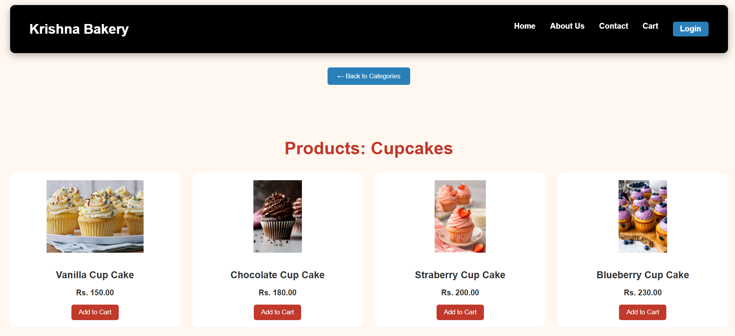
Figure 11 Products Page of Krishna Bakery
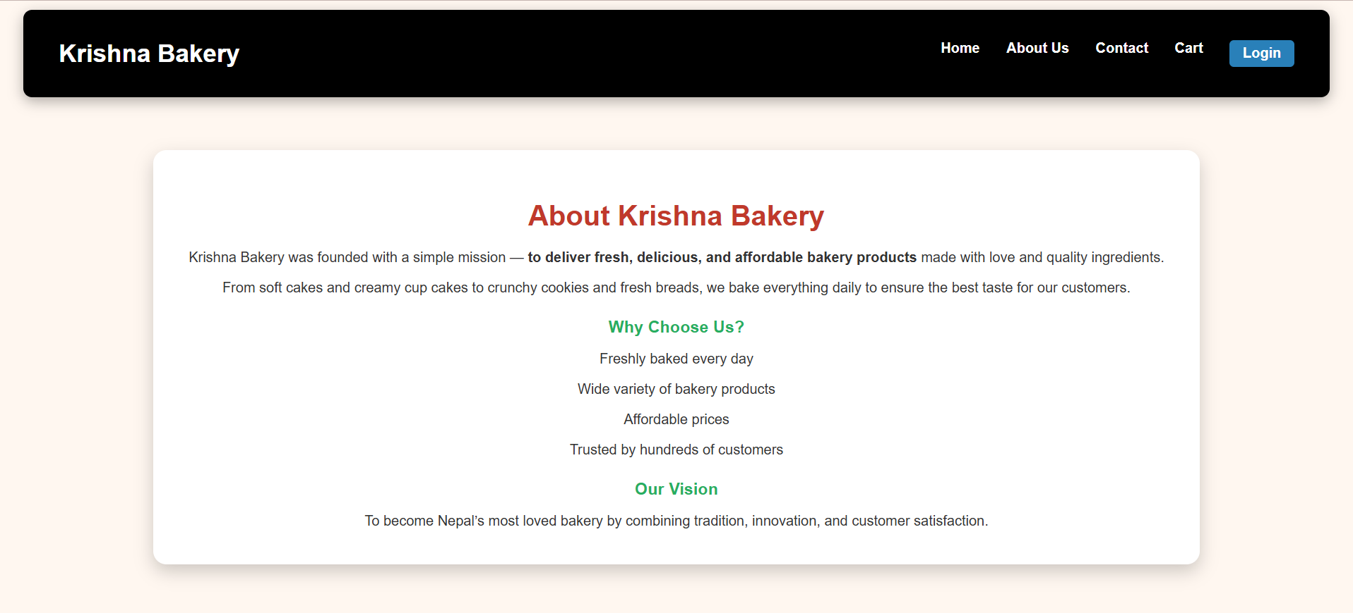
Figure 12 About Us Page of Krishna Bakery
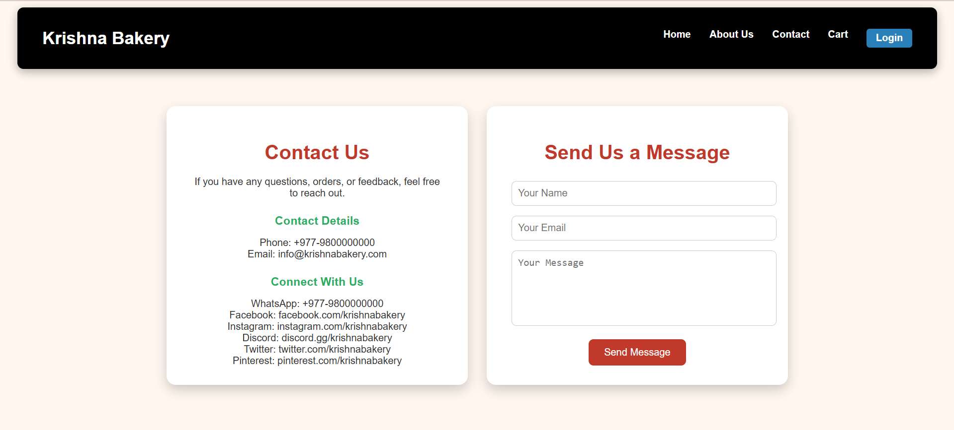
Figure 13 Contact Page of Krishna Bakery

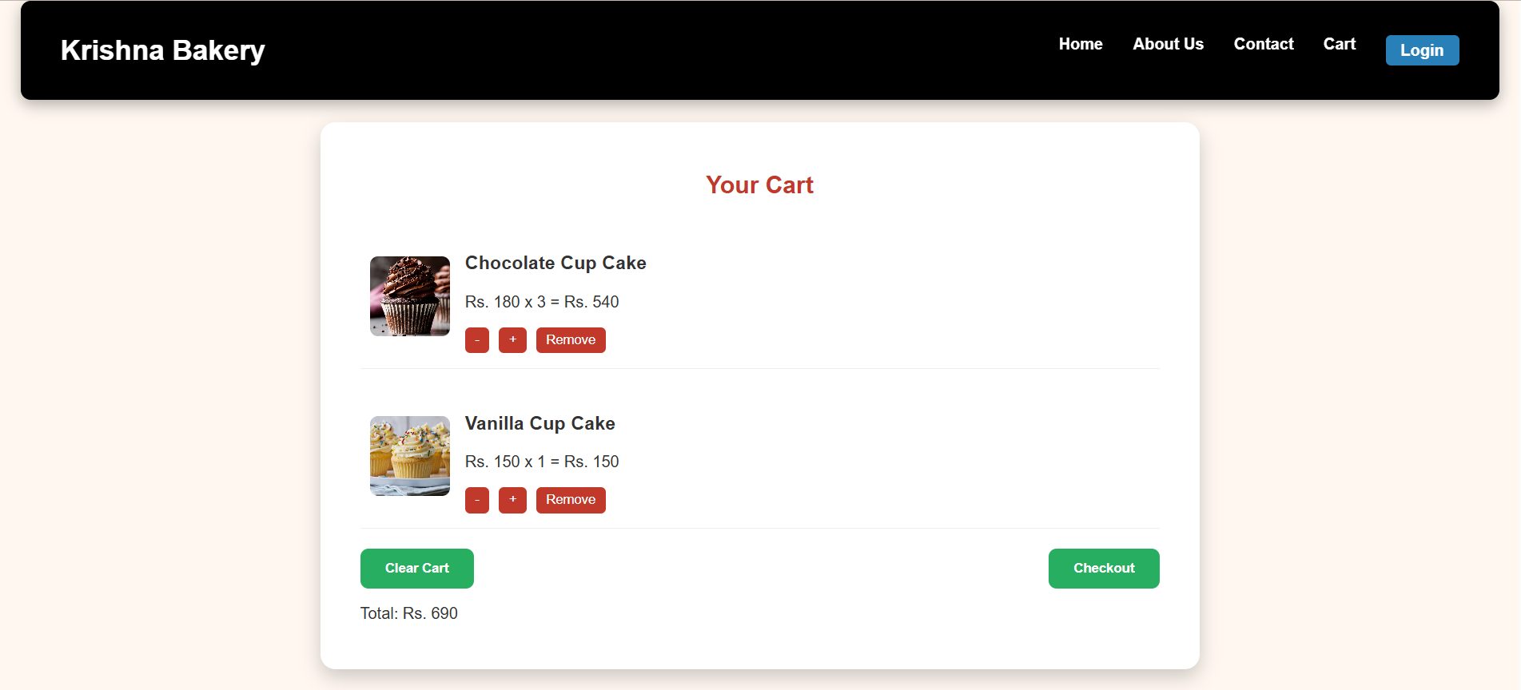
Figure 14 Shopping Cart for Krishna Bakery
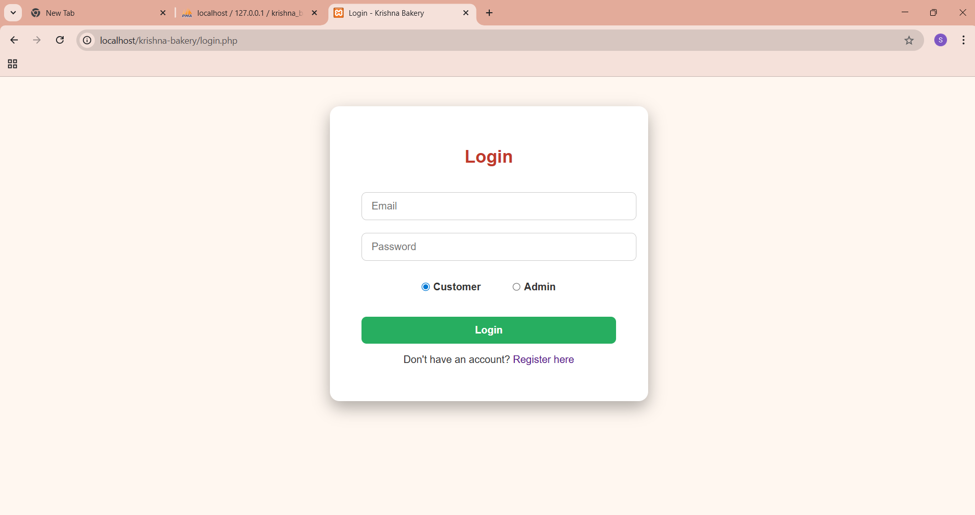
Figure 15 Login Page for Krishna Bakery
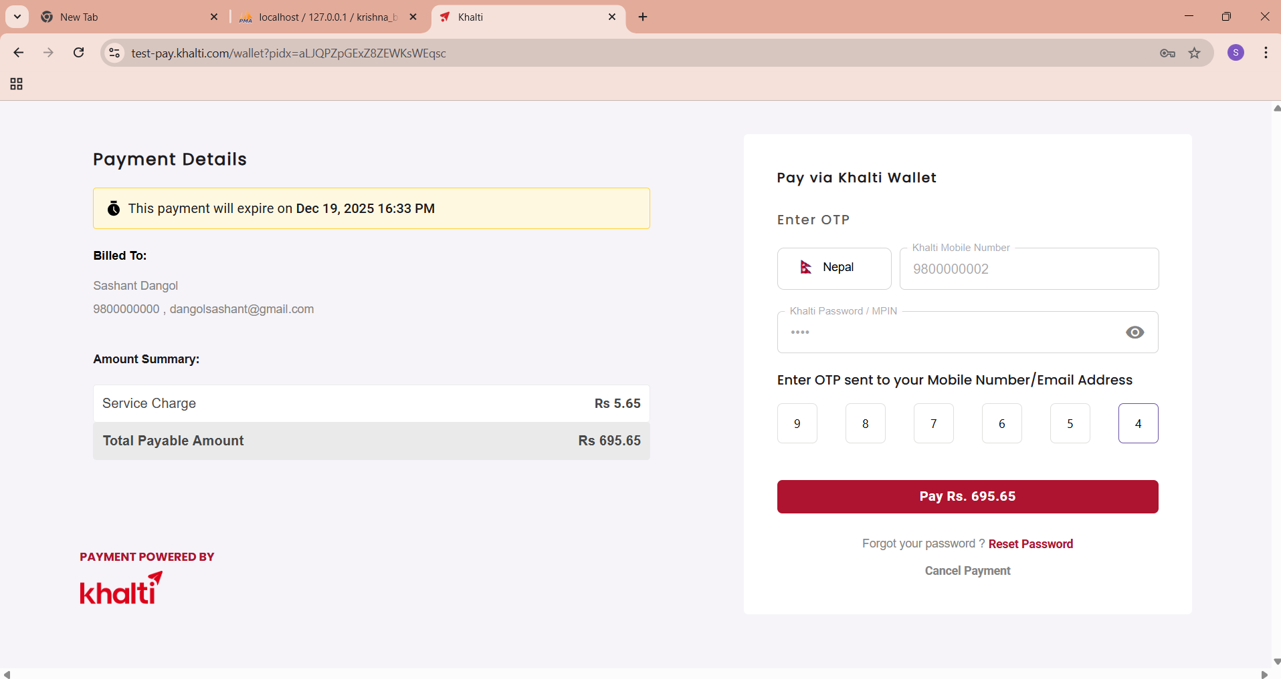
Figure 16 Khalti Payment Integration

